Topic

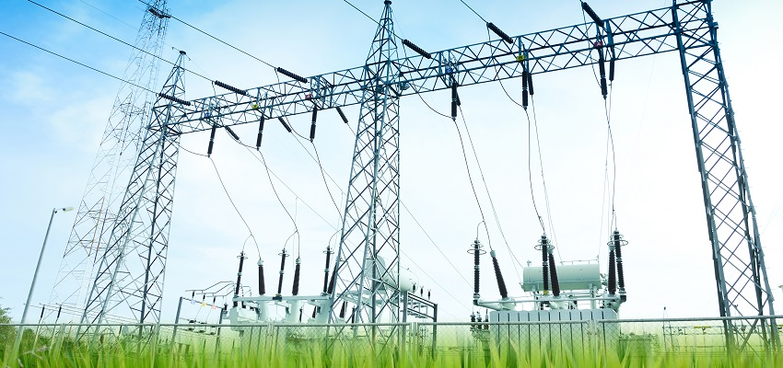

Article title

Article subtitle

Author’s name(s)

**Table of contents summary (ToC)**

Table of contents summary should have up to 300 characters (including spaces). The summary should briefly describe what Article is about and will be placed on the Content page in the Magazine.

Abstract

Abstract should have up to 100 words. Important: Do not use symbols, special characters, or maths in Article title or Abstract.

**Keywords:** component; formatting; style; styling; insert (up to 5 words)

# Introduction

This template provides authors with most of the formatting specifications needed for preparing electronic versions of their articles. All standard article components have been specified for two reasons: (1) ease of use when formatting individual articles, and (2) conformity of style. The desirable size of the article should be up to 6 pages.

# Prepare your article before styling

Before you begin to format your article, first write and save the content as a separate text file. Keep your text and graphic files separate until after the text has been formatted and styled. Do not use hard tabs, and limit use of hard returns to only one return at the end of a paragraph. Do not add any kind of pagination anywhere in the article.

Number your sections (headings and subheadings) consecutively starting from Introduction (1.). Conclusion should not be numbered.

Finally, complete content and organisational editing. Please take note of the following items when choosing topic, title or subtitle, and proofreading spelling and grammar:

## Choosing your topic

Select the topic for your article from the list in the Topics document. You can download it from the magazine website: <https://transformers-magazine.com/files/Topics_TM_10_2016.pdf>.

## Subtitle

Create subtitle by writing a sentence or a question to provide a bit more information about the article and to attract the readers.

## Abbreviations and acronyms

Define abbreviations and acronyms the first time they are used in the text, even after they have been defined in the abstract. Abbreviations such as IEC, IEEE, CIGRE, ac, dc, and rms do not have to be defined. Do not use abbreviations in the title or headlines unless they are unavoidable.

## Units

* Use either SI (MKS) or CGS as primary units. (SI units are encouraged.). An exception would be the use of English units as identifiers in trade, such as “3.5-inch disk drive”.
* Avoid combining SI and CGS units. This often leads to confusion because equations do not balance dimensionally. If you must use mixed units, clearly state the units for each quantity that you use in an equation.
* Do not mix complete spellings and abbreviations of units: “Wb/m2” or “webers per square metre,” not “webers/m2”. Spell units when they appear in text: “...a few henries”, not “...a few H”.
* Use a zero before decimal points: “0.25”, not “.25”. Use “cm3”, not “cc”.

## Equations

The equations are an exception to the prescribed specifications of this template. You will need to determine

whether or not your equation should be typed using either the Arial or the Symbol font (please no other font). To create multileveled equations, it may be necessary to treat the equation as a graphic and insert it into the text after your article is styled.

Number equations consecutively. Equation numbers, within parentheses, are to position flush right, as in (1) and (2), using a right tab stop. To make your equations more compact, you may use the solidus (/), the exp function, or appropriate exponents. *Italicise Roman symbols* for quantities and variables, as in (1), but not Greek symbols, as in (2). Use a long dash rather than a hyphen for a minus sign, as in (1). Punctuate equations with commas or full stops when they are part of a sentence, as in (2).

*a*–*b*=*c* (1)

α+β=γ (2)

Note that the equation is centred using a centre tab stop. Be sure that the symbols in your equation have been defined before or immediately following the equation. Use “(1),” not “Eq. (1)” or “equation (1)” except at the beginning of a sentence: “Equation (1) is ...”

## Some common mistakes

* Avoid using ‘would be’ when describing a real situation. For example: ‘In this case, the current is…’ not ‘In this case, the current would be…”.
* Avoid repetition of phrases. If you need to make a similar point over a number of paragraphs, vary the choice of words. For example: A further function is…; The next function to be considered is…; X is another function…; In addition, function X…, etc.
* If reporting the results of a project or experiment that you have conducted, you should avoid asserting your opinion about what should have happened or why something did or did not happen. You must always back up your statements with supporting details.
* Be careful about using absolute statements like ‘always’ and ‘never’. Remember that all claims must be supported by evidence and very few things are absolute.
* Science writing is formal and concise, much like business writing so contractions should be avoided.
* Some words, like ‘variable’ and ‘significant result’ have very specific meanings in the science world. Make sure you have a clear understanding of what they mean.
* Commas, semi-/colons, full stops, question and exclamation marks are located within quotation marks only when a complete thought or name is cited, such as a title or full quotation. When quotation marks are used, instead of a bold or italic typeface, to highlight a word or phrase, punctuation should appear outside of the quotation marks. A parenthetical phrase or statement at the end of a sentence is punctuated outside of the closing parenthesis (like this). (A parenthetical sentence is punctuated within the parentheses.)
* Number footnotes separately in superscripts. Place the actual footnote at the bottom of the page in which it was cited. Do not put footnotes in the reference list. Use letters for table footnotes.

# Images, figures and tables

With any relevant artwork - **non-copyrighted photos only** - please use your own images or other sources such as Wikimedia Commons, Flickr Creative Commons, or another source that allows photo sharing.

Apart from your own, other acceptable images are the ones released into Public Domain or registered under any Creative Commons Licence which allows usage of the image for any purpose, even commercial. Remember that images taken from Wikimedia Commons or Flickr Creative Commons must also be referenced in the main text and Bibliography. Such images must have a number reference in the main text and the following information in the Bibliography: Author’s name, Image name, Source (website link) and date on which it was inserted into the article.

**Prepare tables in MS Excel** and send them as **separate documents. Graphs and schematic drawings** must be prepared as **separate files** in vector formats (.ai or .eps) or in bitmap formats: jpg, bmp, tif or psd in the minimum resolution of 600 dpi (dots per inch). Cite the tables in the text using Table 1, Table 2, etc.

**Prepare images as separate files** in the following formats: jpg, bmp, png in the minimum resolution of 300 dpi (dots per inch). In order to print a 10 x 10 cm in the magazine, it is necessary to use a 1,200 x 1,200 ppi photo, Fig.1. Figure captions should be below the figures; table heads should appear above the tables. Use the abbreviation “Fig. 1” to refer to the figure, even at the beginning of a sentence.

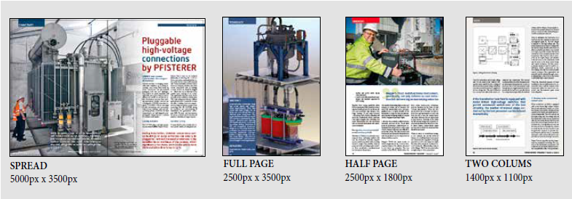

Figure 1. Transformers Magazine image size guide

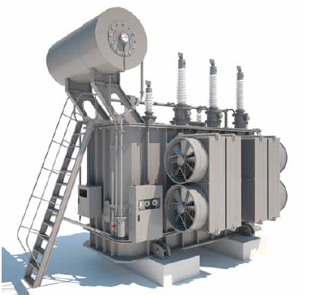

Figure 2. High voltage power transformer

Table1. Diagnosis methods and related problems

|  |  |
| --- | --- |
| **Method** | **Principle** |
| Key gas | Gas identification and proportion |
| Rogers | Ratios of 3 combustible gases |
| Donnenberg | Ratios of 4 combustible gases |
| IEC 599 | Other ratios of same 4 gases |
| Duval Triangle | Graphic Monograph – Triangle |

Figure labels: Use words rather than symbols or abbreviations when writing Figure axis labels to avoid confusing the reader. As an example, write the quantity “Current I”, or “Current I CI”, not just “CI”. If including units in the label, present them within parentheses. Do not label axes only with units. In the example, write “Current [A]”, not just “A.” Do not label axes with a ratio of quantities and units. For example, write “Temperature [K]”, not “Temperature/K”.

# Leads

Leads are text boxes arranged along the article which should attract readers’ attention to read the article. In fact, reading leads and looking at photos makes a reader get the gist of the article. The lead can be the most important sentence, or it can be a summary of a part of text. There can be 1-2 leads per a page.

A lead contains 25-30 words but no more than 40. They should be interesting, even intriguing to catch readers’ attention and to give an insight into what the article is all about. Below is advice for writing leads, which may help you:

* Think about the main focus of the article.
* Set the scene. Creatively depicted scene can intrigue the reader about the event taking place.
* Pick a quote. Perhaps your main source said something interesting that is connected to the main focus of the article.
* Be short and to the point. A short and punchy first sentence (especially one that makes some sort of assertion) can immediately hook the reader.

It is also necessary to mark the position/the paragraph of each lead. Put each lead in parenthesis and number it according to the allocated paragraph. List the leads at the end of your article, after biography(ies). Look at the samples placed at the end of this template for reference.

# Conclusion

This electronic document is a template which defines the components of your article (title, text, heads, etc.) in its style sheet.

Bibliography

Citations should be listed consecutively within brackets [1] in the same order in which they appear in the article text. In the text, refer simply to the reference number, as in [2]. Do not use “Ref. [2]” or “reference [2]” except at the beginning of a sentence: “Reference [2] was the first ...” List only those citations which are quoted in the actual text.

Unless there are six authors or more give all authors’ names; do not use “et al.”. Articles that have not been published, even if they have been submitted for publication, should be cited as “unpublished” [3]. Articles that have been accepted for publication should be cited as “in press” [3]. Capitalise only the first word in the article title, except for proper nouns and element symbols.

For article published in translation journals, please give the English citation first, followed by the original foreign-language citation.

List your citations as in [1-4].

[1] M. Banovic, J. Sanchez, Classification of Transformers Family, Transformers Magazine, Vol 1, No.1, 2014

[2] M. J. Heathcote, J&P Transformer book, Newnes, 13th edition, 2007

[3] IEC chapters 1 to 21 of the 60076 power transformers standards, www.iec.ch

[4] Handbook for Transformers, 3rd edition, ABB, 2010

Authors

Image for biography should be sent as separate file in the following formats: jpg, bmp, png, and in the minimum resolution of 300 dpi.

Authors’ biography should have up to 200 words. The sample biography is below:

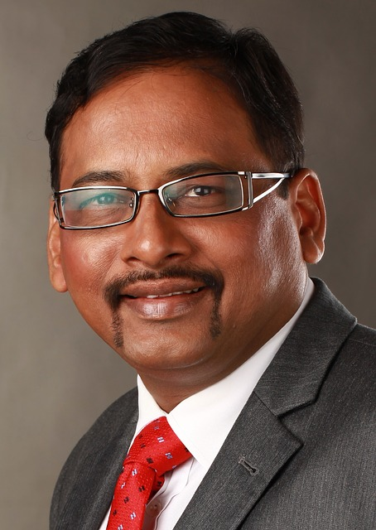**John Smith** completed a PhD in electrical engineering in 2006 and worked in a major American utility. His work involved transformer diagnosis, transmission and distribution lines, and systems. Today he is an active member of the IEEE/PES Transformers Committee and works for a major French utility. He is also a Transformers Magazine editor.

L1: Nowadays, electric energy is available almost everywhere and we do not even think how it was produced. Production of the electric energy is possible by application of power transformers. (2.1)

L2: The theoretical and practical principles of power transformers have remained the same since more than a century ago. (2.3)